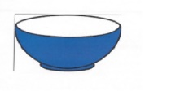

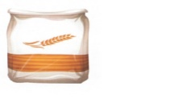
In a bowl, mix :
1 cup of flour
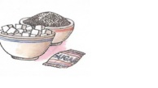
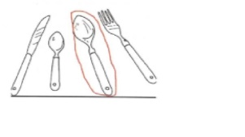
2 tablespoons of sugar
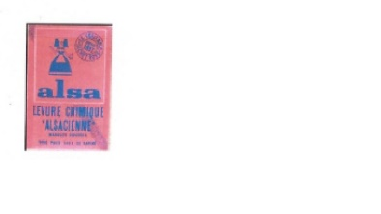
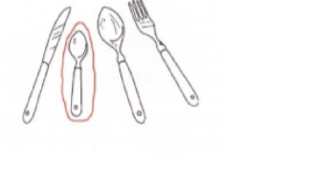
2 teaspoons of baking powder
1 teaspoon of salt

…………………………………………………………………………………………………………………………………………………………
Mix together
………………………………………………………………………………………………
Make a well
………………………………………………………………………………………………
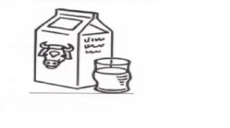
Pour in
a cup of milk
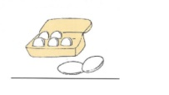
1 egg
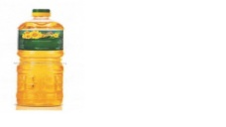
2 tables spoons of oil
…………………………………………………………………………………………………………………………………………………………
Mix
………………………………………………………………………………………………………………………………………………………..
Fry the pancakes.

