LES INSTRUMENTS DE L’HISTOIRE

*Le piano des bois*

[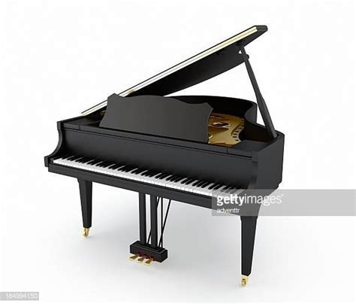](https://media.gettyimages.com/photos/black-grand-piano-picture-id184994150?s=612x612) [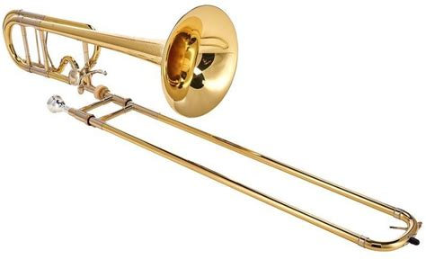](https://1.bp.blogspot.com/-rUj5133CFyM/W5w699mf0kI/AAAAAAAABAw/lhMV8fRWEpcatuSK-VMYetKzGtRudF1LQCLcBGAs/s1600/trombone.JPG)

Un piano un trombone

[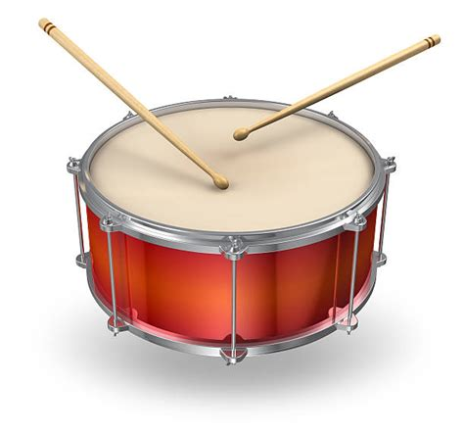](https://media.istockphoto.com/photos/picture-of-a-red-drum-with-two-brown-drumsticks-playing-it-picture-id148322947?k=6&m=148322947&s=612x612&w=0&h=g_NJY_emvawE6M6DC1xD6Z72pNnGl-MoFx8qipsgJIY=) [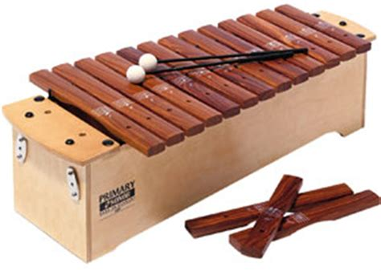](http://az58332.vo.msecnd.net/e88dd2e9fff747f090c792316c22131c/Images/Products22482-1200x1200-488148.jpg) [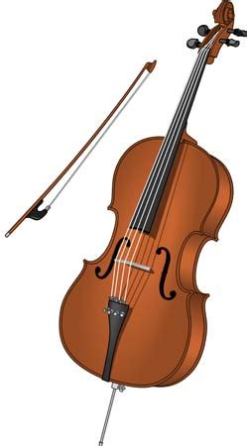](https://cdn.britannica.com/70/129670-004-8AF33352.jpg)

Un tambour un xylophone un violoncelle

[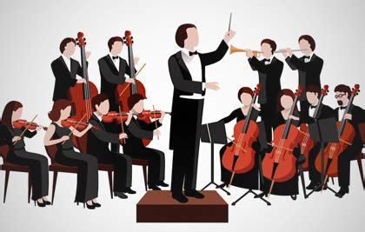](http://bepartoftheorchestra.org/images/portfolio/thumbs/image4.jpg)

Un orchestre avec le chef d’orchestre